Clean Architecture
- Clean Architecture is a software architecture style introduced by Robert C. Martin (Uncle Bob). Its goal is to create highly maintainable, testable, and independent systems.
- Clean architecture is a software design approach that emphasizes the separation of concerns, making systems easier to maintain, test, and scale.
- It organizes software into distinct layers, each with a specific responsibility, ensuring that the core business logic remains independent of external frameworks, UI, databases, and delivery mechanisms
- Clean Architecture is a set of principles and a layered architecture pattern that helps you build systems that are maintainable, testable, independent of frameworks, and adaptable to change. The big idea is separation of concerns + dependency rule: inner layers know nothing about outer layers; outer layers depend on inner layers (via interfaces/abstractions).
- 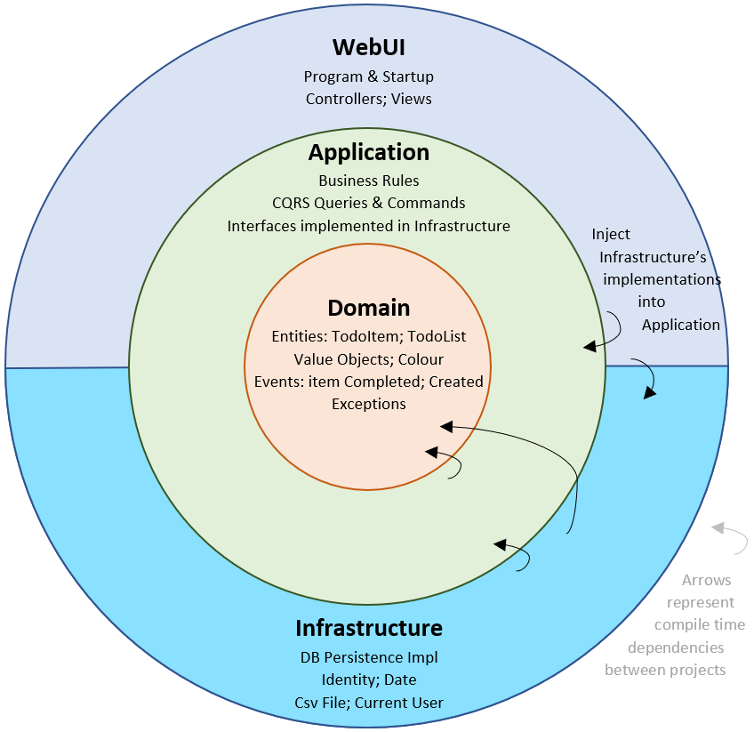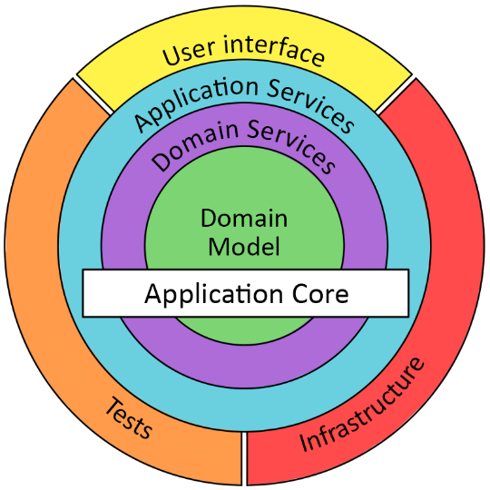

🎯 What Clean Architecture Achieves
- Independent of Frameworks
The architecture does not depend on ASP.NET Core, EF Core, SQL Server, or any external tool.
- Independent of UI
You can switch from Web API → MVC → Blazor → gRPC without modifying domain logic.
- Independent of Database
You can replace SQL Server with PostgreSQL, Oracle, MongoDB, or an in-memory DB easily.
- Testable
Business rules can be unit-tested without infrastructure.

🔁Clean Architecture — Layer Overview
A typical ASP.NET Core Clean Architecture solution has 4 layers:
1️⃣ Domain Layer (Core Business Logic)
- Contains entities, enums, value objects, domain events, interfaces (only if needed).
- No database code, no HTTP code.
- Pure C# classes.
  - What: Enterprise-wide business rules, core domain models (rich domain objects or simple POCOs).
  - Responsibility: Hold state and domain logic that won't change if UI or DB changes.
  - Examples: Order, Customer, domain value objects, domain exceptions, invariants.
  - Characteristics: Pure, testable, no framework dependencies.
2️⃣ Application Layer (Use Cases / Interactors / Application Services)
- This is where business rules live. Contains:
- Interfaces (Repository/Service contracts)( No EF Core here — only interfaces.)
- DTOs
- CQRS (Commands/Queries)
- Validators
- Services
  - What: Application-specific business rules. Orchestrates entities to accomplish application tasks.
  - Responsibility: Implement use cases (e.g., CreateOrder, CancelOrder, GetCustomerSummary), coordinate repositories/gateways, enforce application-level rules.
  - Characteristics: Knows interfaces (ports) for persistence, messaging, etc., but uses abstractions — not implementations.
  - Testability: Very high — inject fake repositories to test the use case.
3️⃣ Infrastructure Layer (Implementation of Interfaces)
- This layer talks to:
- EF Core
- SQL Server
- Logging
- Authentication
- File storage
- It implements the interfaces defined in Application Layer/Domain Layer.
  - What: Concrete implementations: EF Core, SQL Server, File System, external APIs, ASP.NET Core framework glue.
  - Responsibility: Provide concrete implementations of interfaces defined by the inner layers (e.g., IOrderRepository), external integrations, configuration.
  - Placement: Outermost layer — infrastructure code depends on inner layers (interfaces) but not vice versa.

4️⃣ Presentation Layer (UI = ASP.NET Core Web API)
- Contains Controllers
- Minimal endpoints
- DI setup
- This layer interacts with Application Layer.
  - What: Translate between outer layer models (HTTP, DB rows, UI view models) and inner models (Entities, UseCase DTOs).
  - Responsibility: Convert requests/responses, implement interfaces required by use cases (repositories/gateways) and adapt them to infrastructure implementations.
  - Common components: Controllers (API layer), Presenters/ViewModels, Repository interfaces implementation skeletons that call EF/SQL.
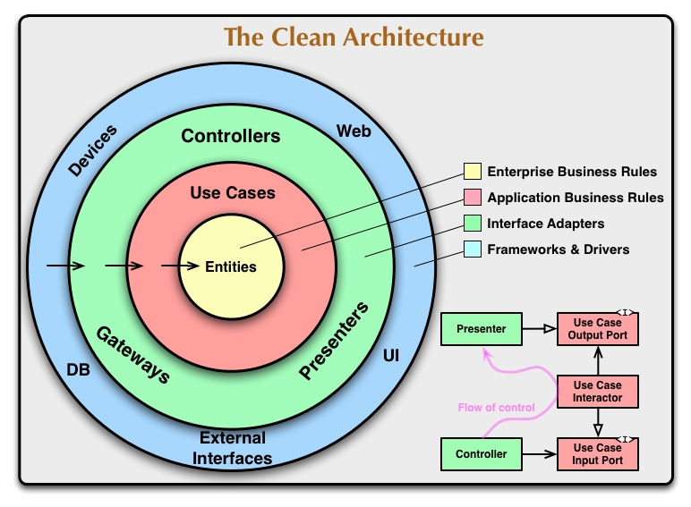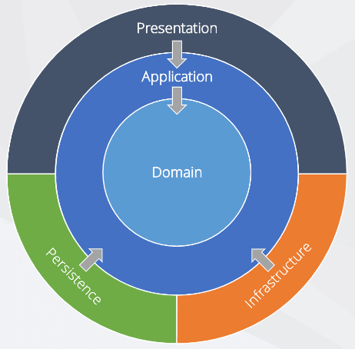
High-level goals
- Independence from frameworks — framework code (ASP.NET, EF Core) stays at the edges.
- Testability — core business rules are easy to unit-test (no HTTP, DB, or disk I/O).
- UI/Database/Infrastructure replaceability — change DB or UI without touching business rules.
- Clear boundaries — each layer has a single responsibility and clear API.
🎯 Clean Architecture Rule
- 👉 Dependencies must always point inward.
- UI → Application → Domain
- Infrastructure → Application → Domain
- Domain should NOT depend on any other layer.
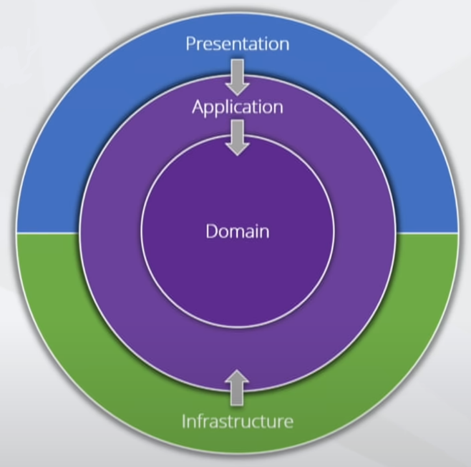

All dependencies must point inward.
Depends On | Does NOT depend on
Presentation → Application | Application → Presentation
Application → Domain | Domain → Application
Infrastructure → Application | Application → Infrastructure

💡 Why This Rule?
Because core business logic should not change when:
- You replace the database
- You switch UI
- You change logging framework
- You migrate from ASP.NET Core 7 → .NET 8 → .NET 10
Your domain remains untouched.

🧠 Why Clean Architecture Is Used in Real Projects?
✔ Easy to test
✔ Easy to change database
✔ Easy to migrate UI (Web API → UI → Mobile App)
✔ Code separation improves maintenance
✔ Clear responsibility boundaries
🌟 Benefits of Clean Architecture
Benefit | Explanation
Testability | Domain and Application layers are easy to unit test.
Flexibility | Easy to replace DB, UI, frameworks.
Maintainability | Clear separation of responsibilities.
Scalability | Supports microservices and modular architectures.
Long-term sustainability | Reduces technical debt.

🎓 Summary
Layer | Responsibility | Should Know About
Domain | Entities + Business Rules | Nothing outside itself
Application | Use cases + Orchestration | Domain
Infrastructure | EF Core, DB, Email, Files | Application
Presentation | API controllers | Application

